Power BI

Microsoft.

analyze and visualize the data.

Business Intelligence – Right data to right people at right time for better decisions.

**3 waves**

1. IT for data insights
2. Analyst to End user
3. End user - Data Visualization.

Raw Data sets.

Data visualization:

Why PowerBI-

Real Time Trends/ Auto search / Advanced analytics/ Custom visualization/ Enterprise Ready.



Key benefits:

Pre-built dashboards

Real time dashboard updates

Secure connection to Data sources

Natural language query (English)

Fast deployment.

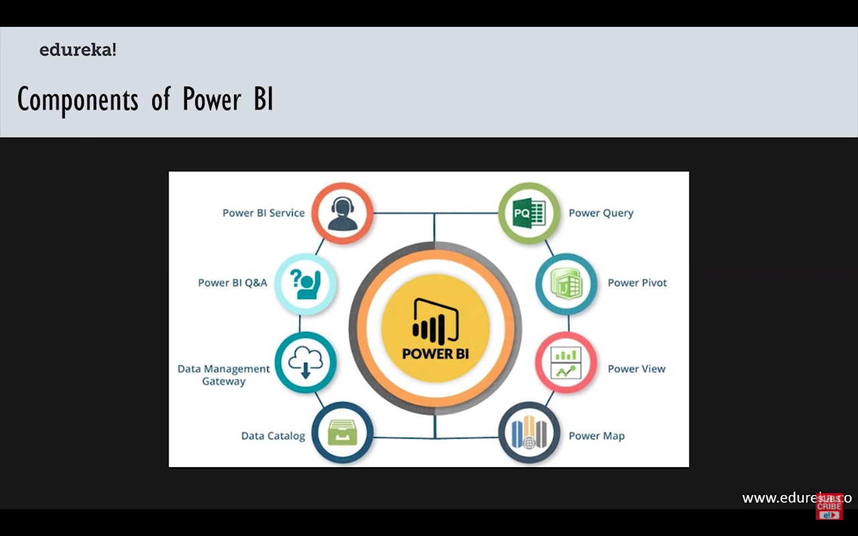

Architecture: 3 phases

1. Data Integration – extracted from sources and integrated in standard format and stored in staging
2. Data processing – Data set preprocessed/cleaned – loaded to Data warehouse
3. Data presentation – visualization.

Install Web App

1. Get data

Visualization

(save)

Or

Publish

Report in .pbix format

powerBi.com interface – a cloud service.

1. Joining Data sources

* Create and modify interactive Visuals.

1. Building and sharing Dashboard.

Pin visuals to a Dashboard.

A QR code for every Dashboard.

Report workspace – Reports/ Visuals are created.

Bing map engines for Maps in MSBI.

**PowerBI KPI**



Target and Trend

Base Measure, Target measure and Threshold.

Power KPI – multiple KPIs.

Custom KPI

PowerBI Dashboard



Dashboards are created in PowerBI service which is an online platform.

Reports are published in to PowerBI service in .pbix format.

Key points of Power BI:

Measures are calculated dynamically and are not stored in the model.

